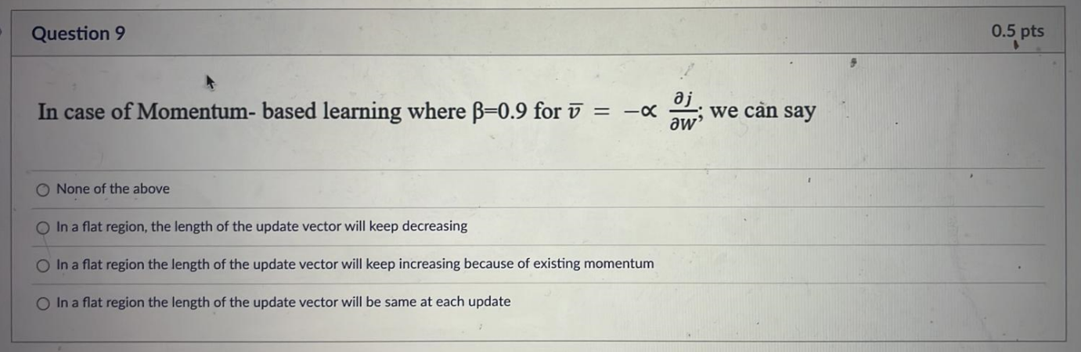

Ans.b

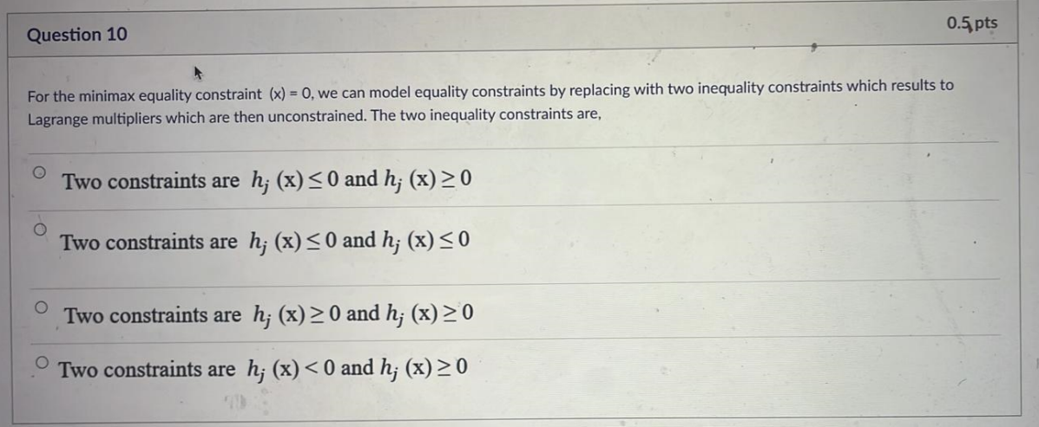ans. A

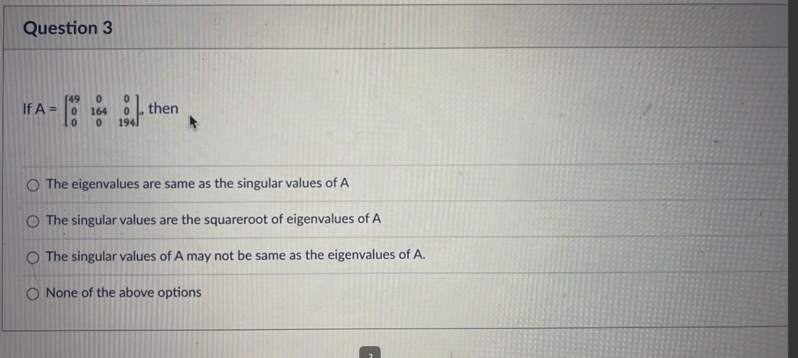ans:c

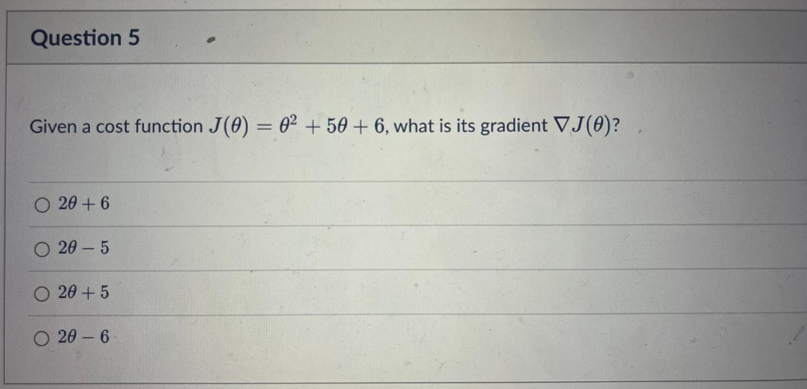ans. C

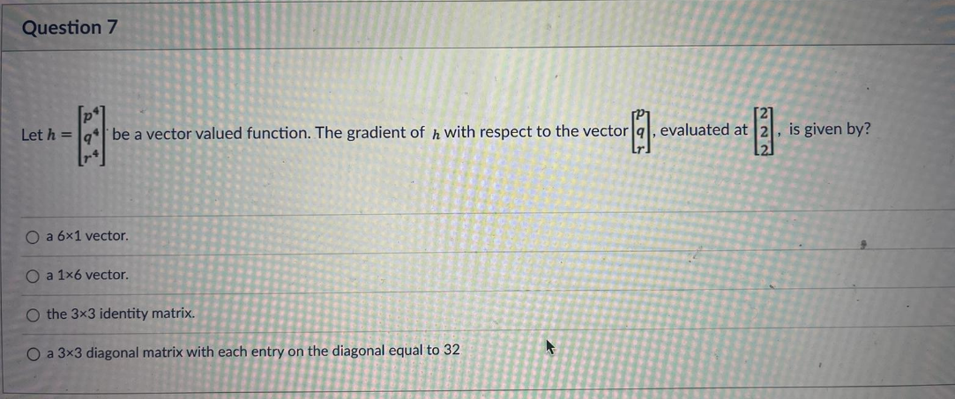

Ans. D

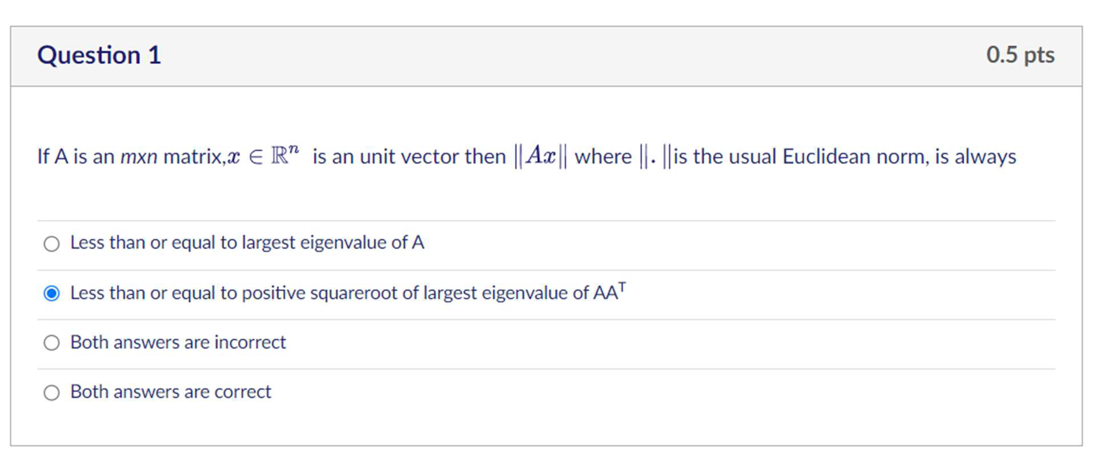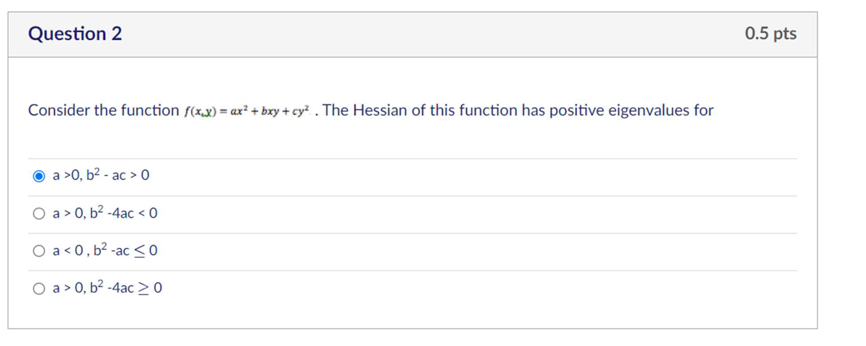

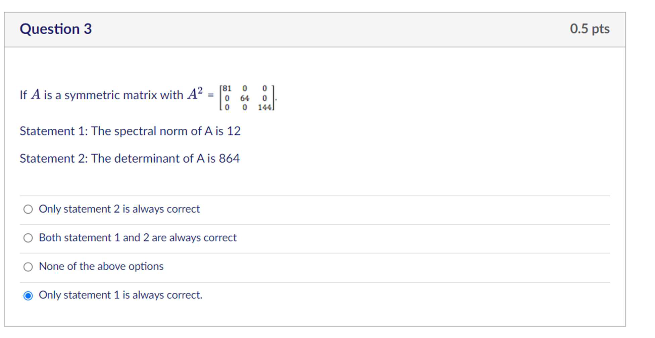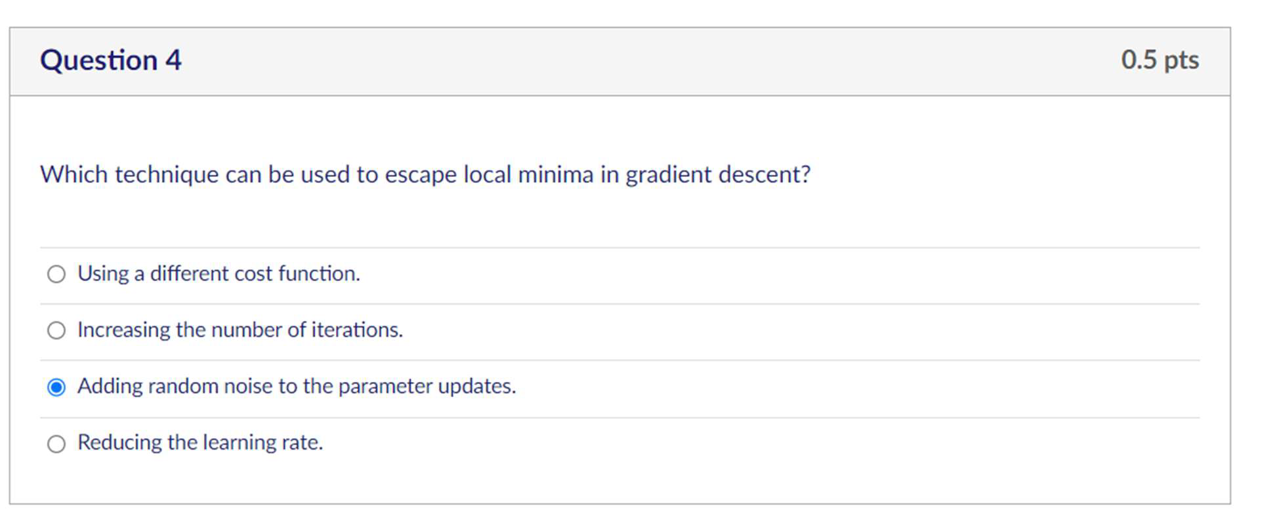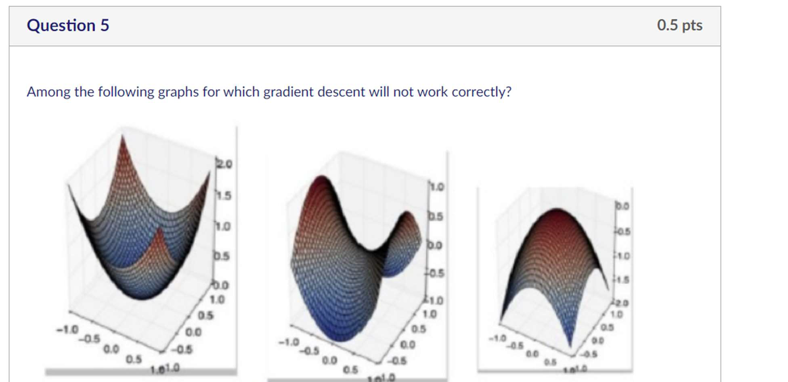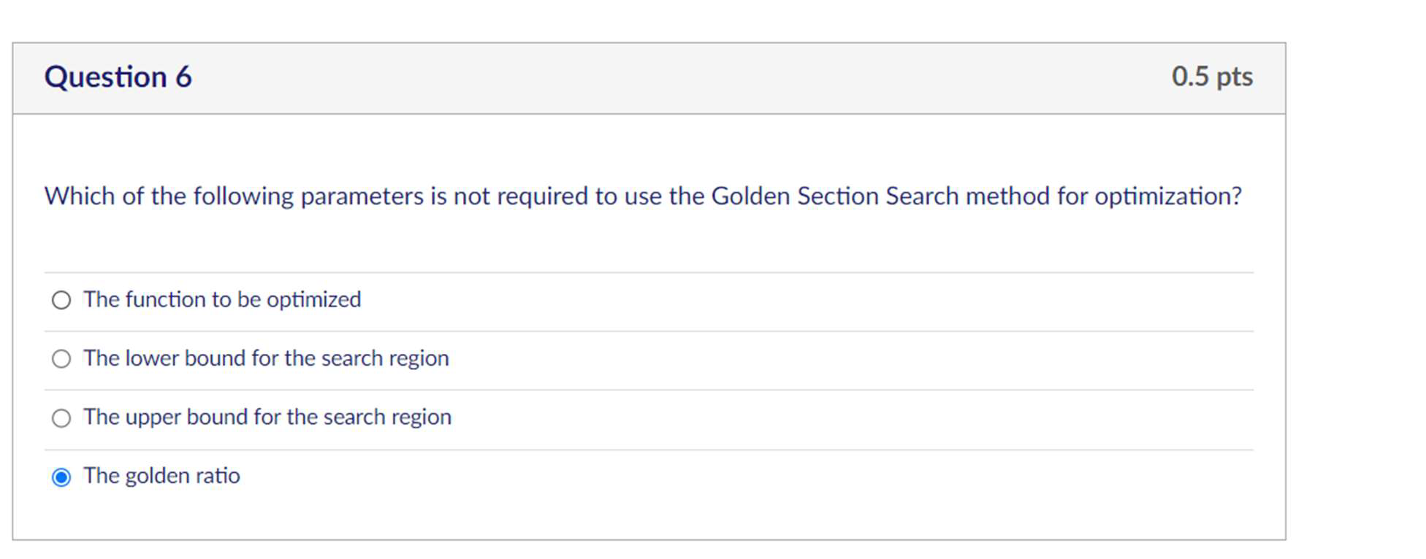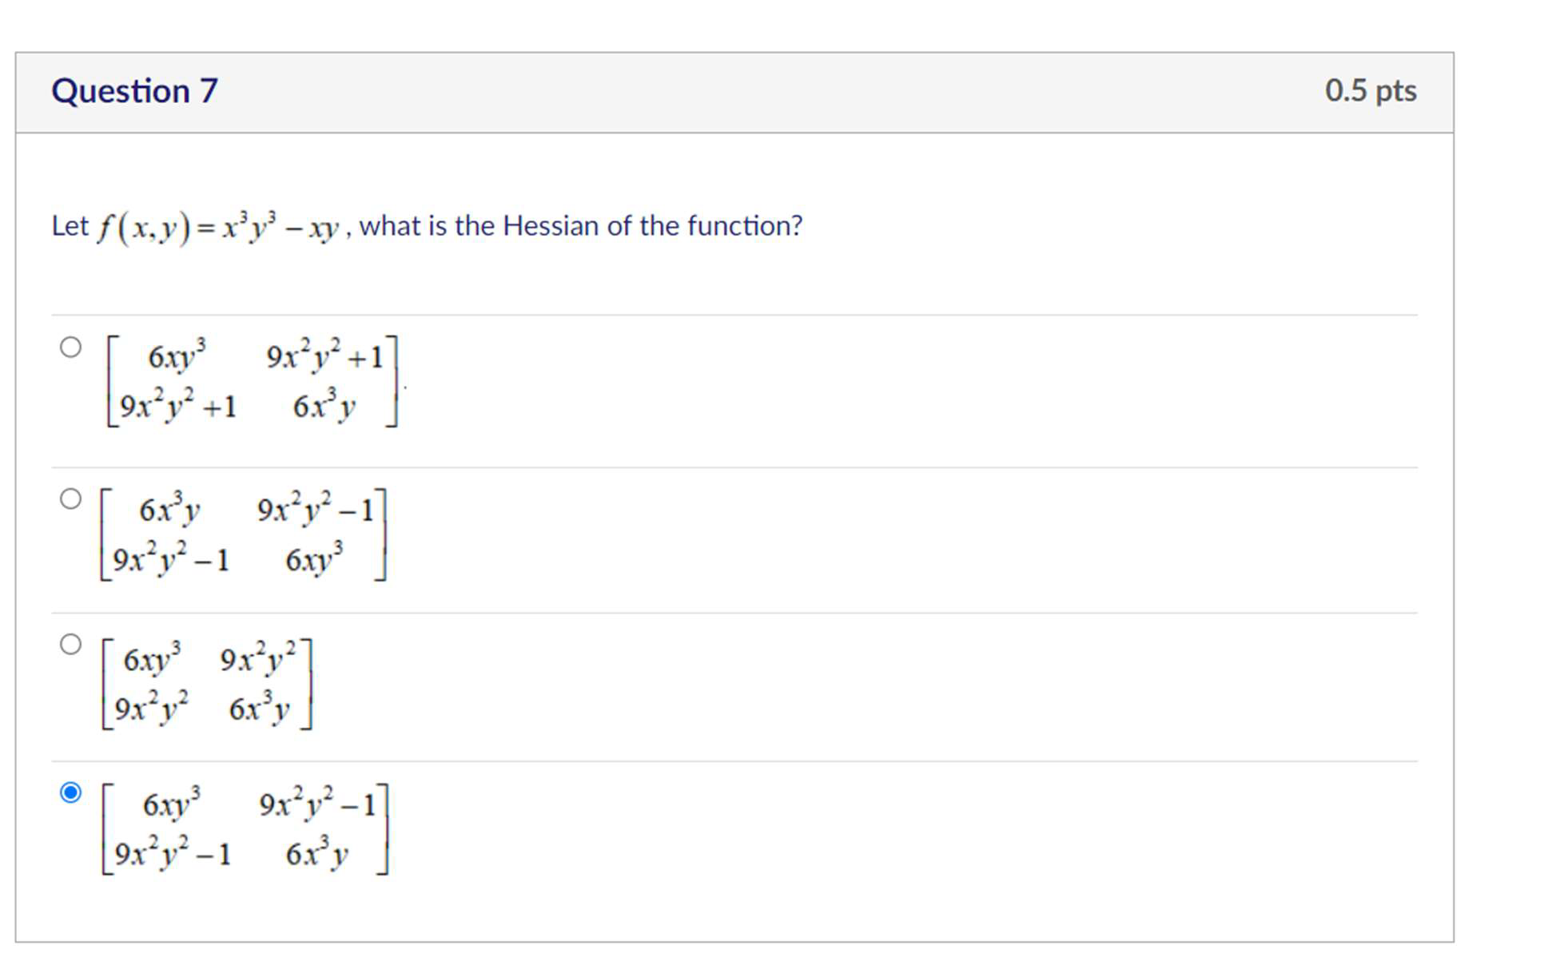

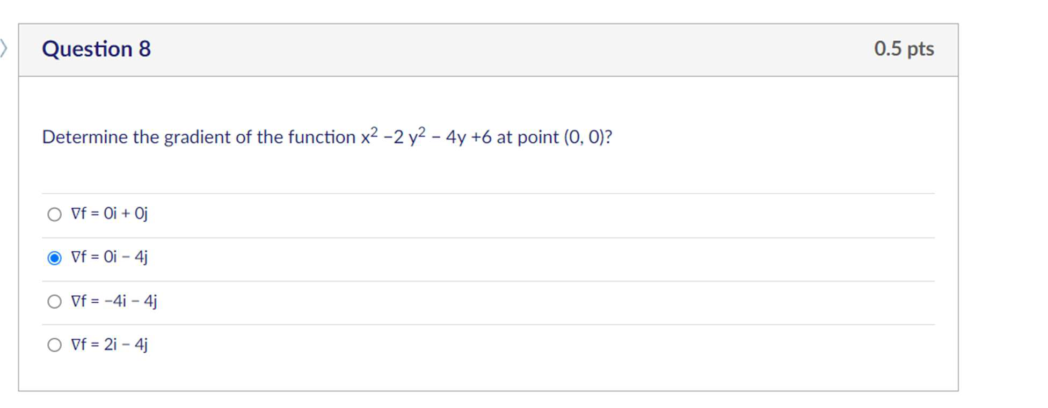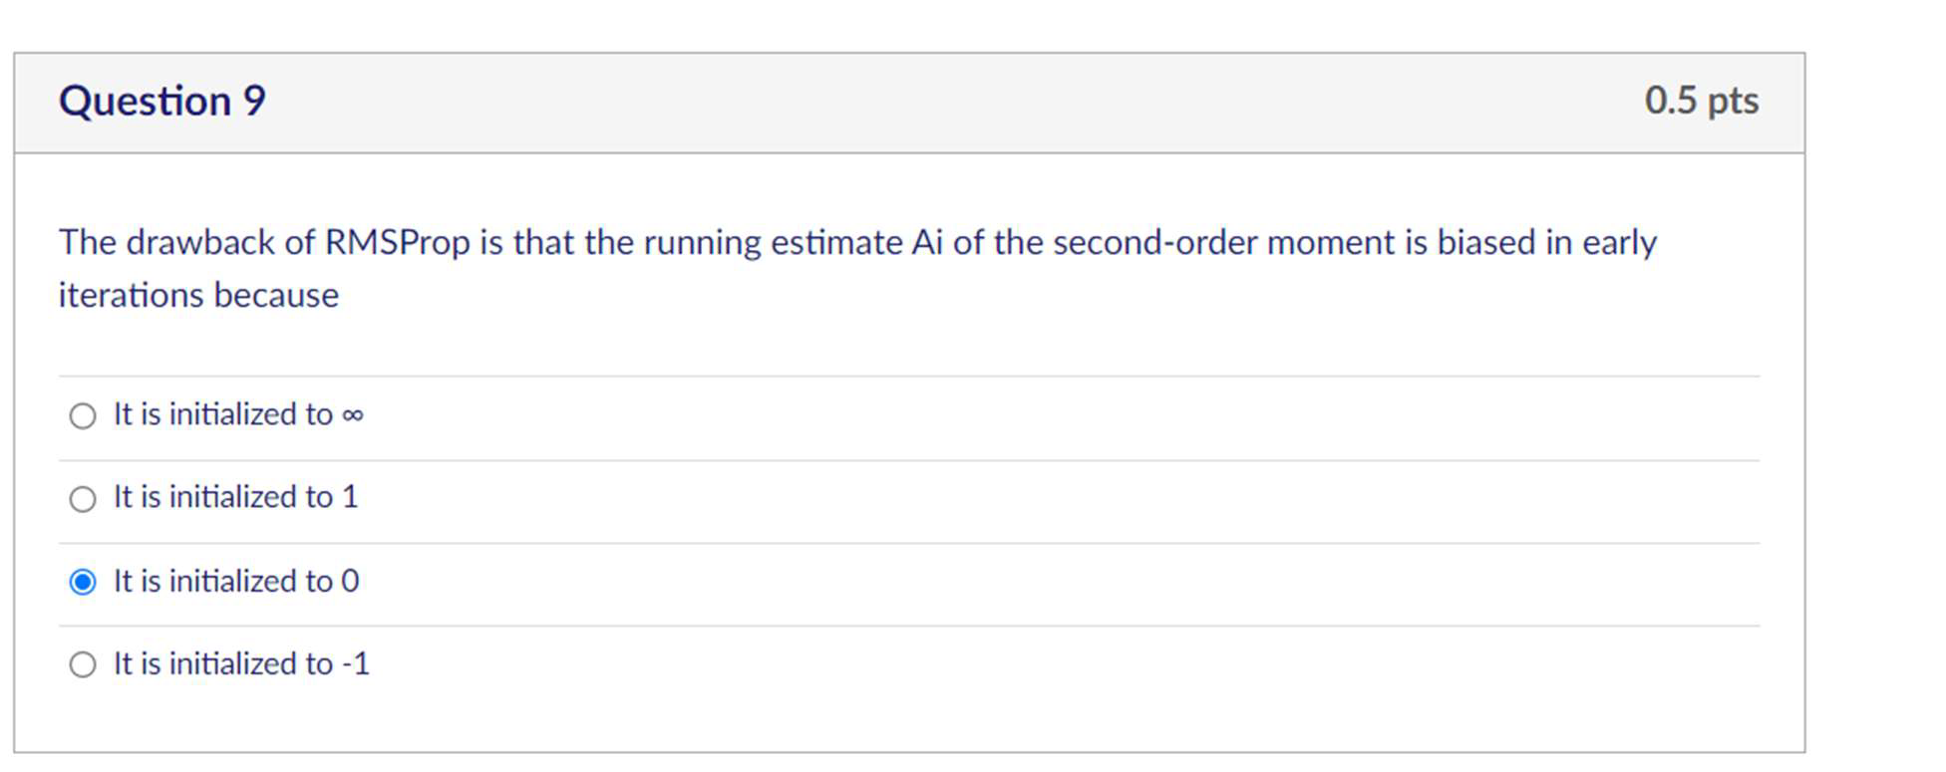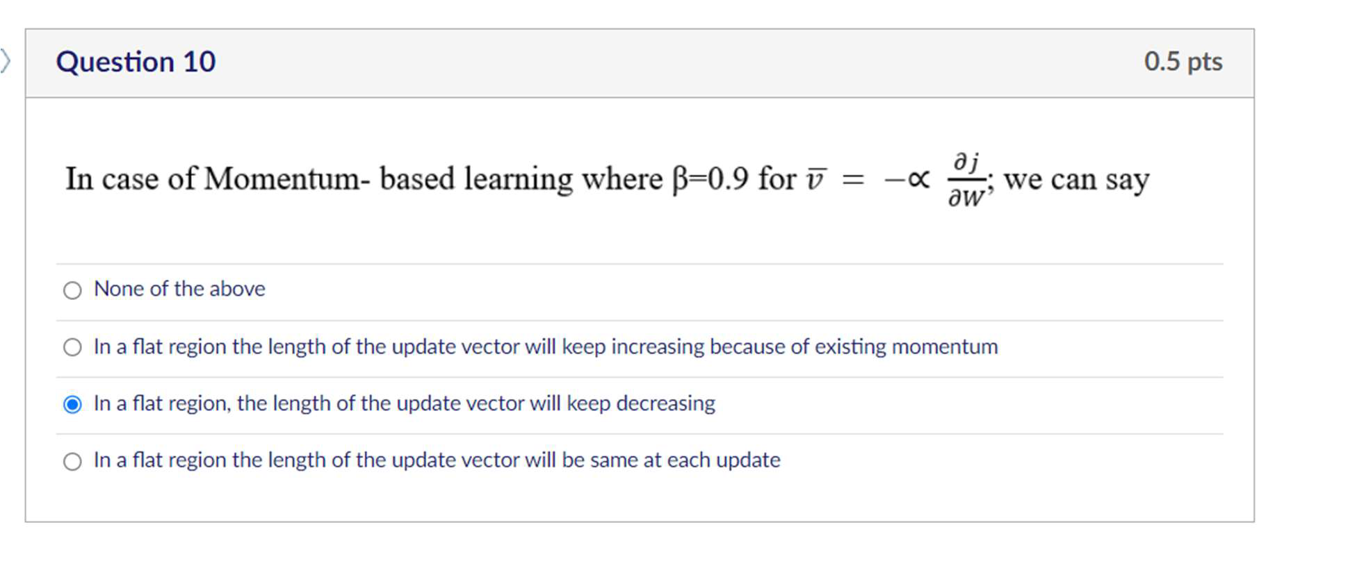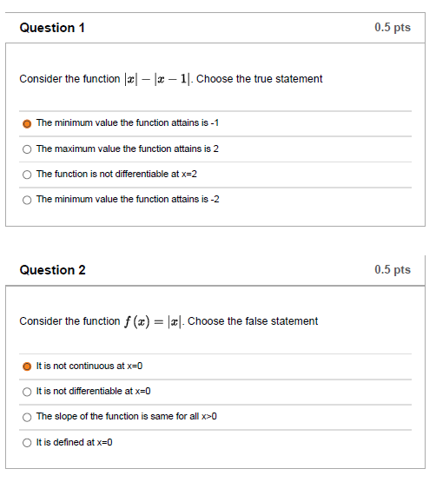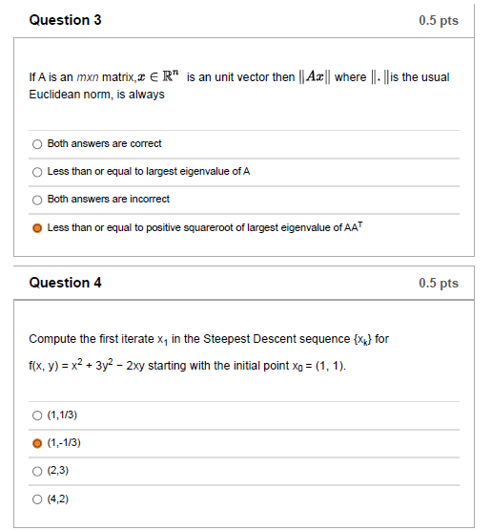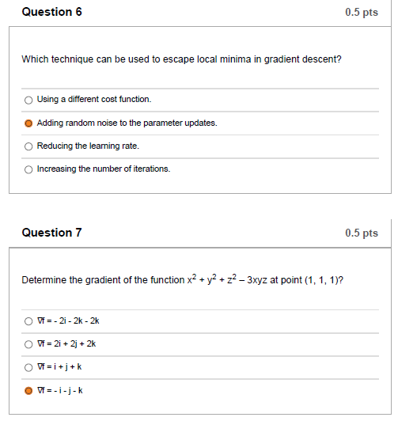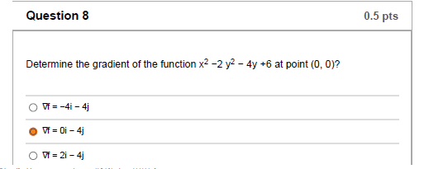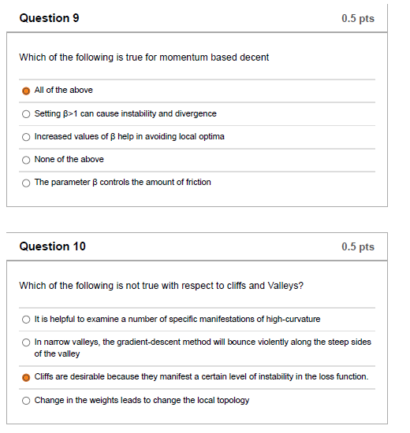

Let [p^4,q^4,r^4] be a vector valued function. The gradient of h with respect to the vector [p,q,r], evaluated at [2,2,2], is given by?

Group of answer choices

a 6×1 vector.

the 3×3 identity matrix.

a 3×3 diagonal matrix with each entry on the diagonal equal to 32

a 1×6 vector.

What is the gradient of the function x^2+2y^2-4y+6 at point (0,0)?

Group of answer choices

a. (-4,-4)

b. (0,-4)

c. (2,-4)

d. (0,4)

Which of the following best describes the gradient descent algorithm?

Group of answer choices

a. An optimization algorithm for finding the minimum of a function.

b. A supervised learning algorithm.

c. A clustering algorithm.

d. A dimensionality reduction algorithm.

Determine the determinant of Hessian of the function x3 + 3y3 – 6x + 8 at point (1, 1)?

Group of answer choices

a. 108

b. 111

c. 109

d. 110

What are the gradient and the determinant of the Hessian of the function f (x, y) =x^2+y^2 at its global optimum?

a. ∇f = 1i +1j and |H| = 0

b. ∇f = 0i + 0j and |H| = 0

c. ∇f = 1i +1j and |H| < 0

d. ∇f = 0i + 0j and |H| > 0

Apply the Method of Steepest Descent to the function

f(x, y) = 4x^2− 4xy + 2y^2

with initial point x0 = (2, 3). Find the first iterate x1

a. 1,1

b. 2,3

c. 5,9

d. 0,1